The EASiHE (E-Assessment in Higher Education) Project
Spanish Language Stage 7 Case Study Overview
August 2010

David Bacigalupo¹, Bill Warburton¹, Lester Gilbert², Gary Wills²
¹MLE Team, iSolutions, ²School of Electronics and Computer Science
University of Southampton SO17 1BJ

Introduction
The EASiHE project has developed a solution for formative e-Assessment, using services currently available within the JISC eFramework. Examples of these services include QTI Engine, Peer Pigeon, LexDis, QTI Migration Tool and Edshare. A joint School of Electronics and Computer Science and iSolutions project, we have worked with five schools across the University. These are the:

- School of Medicine,
- School of Health Sciences,
- School of Civil Engineering and the Environment,
- School of Humanities and
- School of Electronics and Computer Science.

In addition, we have conducted a benefits realisation project to extend our work to Bournemouth and Poole College. The five schools and Bournemouth and Poole College have been our six EASiHE case studies.

The work has received positive feedback from lecturer and student evaluations, University senior management via our advisory panel, and from the wider community as we disseminate our results. Our aim is to ensure that these results are of both short-term and long-term benefit to the University of Southampton, as well as the national and international HE community.

This document gives an overview of the work done for the School of Humanities (Spanish Language Stage 7) case study
.
University of Southampton Team | Bournemouth and Poole College Team
- David Bacigalupo  - Lester Gilbert  - Bart Nagel  - Onjira Sitthisak  - Sue Walters  - Bill Warburton  - Gary Wills  - Pei Zhang | - Chris Frost  - Paul Kirby

http://www.soton.ac.uk/easihe/
gbw@ecs.soton.ac.uk (Southampton Principle Investigator)
D.Bacigalupo@soton.ac.uk (Southampton Project Manager)

Table of Contents

Introduction 1
Table of Contents 2
Part 1: Introduction 3
1. About the Spanish Language Stage 7 Module 3
2. The Process We Went Through 4
2.1 Timeline 4
2.2. Documentation of this Process 4
Part 2: The Solution: Basic Functionality 5
1. The Basics 5
1.1. How to Access the System 5
1.2. Prerequisites – Using 5
1.3. Prerequisites – Editing 5
2. Basic Functionality 5
2.1. Author Uses Perception to Create eAssessment 5
2.2. Users do eAssessment and Get Feedback 6
2.3. Author Generates Report on How Well the Users are Doing on the Perception eAssessments 9
3. Making eAssessments More Accessible 10
4. Hot Potatoes eAssessments 12
5. Other Information 12
Part 3: The Solution: Advanced Functionality 13
1. Introduction 13
2. User Feedback and QTI 13
2.1. Users as “Web 2.0” can help the Author by Leaving Comments and Rating the eAssessment 13
2.2. Author converts eAssessment Questions to QTI v2 standard 15
2.3. Users do eAssessment (using QTI engine delivery engine) 17
3. The EASiHE Repository and QTI Editors 18
3.1. The Repository 18
3.2. Editing the eAssessment Questions 19
3.3. Mobile-Optimised eAssessment Question Editing 22
Part 4: Further Information 24
1. Further Information about this Case Study 24
3. Extended Version of Parts 2 and 3 of this Document 25
4. The EASiHE Website 25
Part 5: Possible Discussion Items for Next Meeting 26
Minor notes 26

Part 1: Introduction

1. About the Spanish Language Stage 7 Module
Spanish Language Stage 7 (SPAN9013) is an advanced-level Spanish module for final year students. The SPAN9013 module lasts for two semesters, with three classes each week. Typically there are around 20-30 students on the module. Prior to the EASiHE involvement the optional independent study web-based formative eAssessments were as follows, with typically one or more eAssessment per study week. They were implemented using Hot Potatoes and accessed via Blackboard, the module virtual learning environment (VLE). They required the students to first play an audio/video media file (in Spanish) before undertaking the assessed questions. Categories of eAssesment that could be automatically marked included: i.) assessing understanding of the media file (typically multiple choice questions); ii.) transcribing the media file using closed procedure (fill in the gap) questions; and iii.) a vocabulary test (also multiple choice). During the last ~10 years, this kind of eAssessment solution has been found to be something motivated students can use independently to practice their language skills.

The following is a summary of the stage 7 “listening” language skills learning outcomes and questions as received from Irina Nelson 25th June 2009.
“Understand with relative ease in most situations and registers, including the media and specialist areas within the aims of the course.
Understand most of the implications and intentions, including humour and irony, of spoken language delivered in a range of accents and registers and at any speed.
Understand with ease virtually everything that is heard. Engage with the subtleties of meaning and nuance in spoken language.
Ability to assess critically the impact of the key social and political issues that take place in the society where the target language is spoken
This requires acquisition of specific vocabulary, correct grammar and syntax as well as pragmatic issues of the target language.

More information is available from the Language Stages Descriptors:
5 http://www.soton.ac.uk/cls/courses/cls_5.pdf
6 http://www.soton.ac.uk/cls/courses/cls_6.pdf
7 http://www.soton.ac.uk/cls/courses/cls_7.pdf”

2. The Process We Went Through
In this case study we went through a process of co-design with the course leader, and in parallel a process of implementation, testing and documentation. As a result of this, we produced a set of eAssessments using our eAssessment tools. The focus in this case study was on: the use of video and audio clips; making eAssessments accessible; techniques for motivating students to use the eAssessments; making the use of eAssessments over multiple academic years more sustainable; reports; how to use the virtual learning environment (VLE) and eAssessment delivery engine in a more coordinated fashion; student-generated feedback exercises; and comparing different eAssessment toolsets. The eAssessment toolsets we compared were: the Perception commercial toolset; our tools (which support the IMS Question Test Interoperability QTI 2.1 specification); and the Hot Potatoes toolset, which is freeware but does not support QTI.

2.1 Timeline
- November 2008: EASiHE project starts
- Early 2009: Initial discussions between EASiHE team and Irina Nelson
- April 2009: David Bacigalupo joins EASiHE project
- May -June 2009 co-design meetings with David Bacigalupo and Irina Nelson
  - In total aprox seven hours of face to face meetings
  - Co-design includes outlining desirable extensions including mock-up of improved format for reports
- June 2009: evaluation of system with Irina Nelson
- Summer 2009
  - Spanish Language eAssessments evaluated by undergraduate student volunteers from the module.
  - David finishes system and associated testing and makes system and documentation available via:
    - http://users.ecs.soton.ac.uk/db1f08/spanish/
- September 2009: end of EASiHE phase 1
- October 2009-March 2010: EASiHE phase 2; additional software created and added to Spanish Language solution; updates sent to Irina during this process.
- April 2010: EASiHE phase 3 (embedding) starts
- Summer 2010
  - Preparation for eAssessments to be used on the module by the EASiHE team on a best-effort basis (due to reduced project funding during phase 3)
  - Handover of case study from David to Bill Warburton

2.2. Documentation of this Process
- See EASIHE Wiki
  - In particular: http://wiki.easihe.ecs.soton.ac.uk/index.php/User_talk:Db1f08
- See EASIHE Blog
- Case study details document on EASIHE website
- Older versions of case study details document for previous iterations
- See personas_scenarios directory (see part 4)
- See archive of screencasts created as system created (see part 4)
- Other documents and webpages on the EASIHE website.
Part 2: The Solution: Basic Functionality

1. The Basics

1.1. How to Access the System
The system is accessed via blackboard.soton.ac.uk – currently in a module called “Spanish Language Stage 7 – test”

1.2. Prerequisites – Using

- Access to Blackboard
- Permission to view the module in Blackboard
- The system has only been tested on Internet Explorer – on other web browsers it should function correctly
- Software and codecs that can play the media files (including various real player codecs, avi, mpg, mp3 etc…)

1.3. Prerequisites – Editing

- Please contact David Bacigalupo or Bill Warburton for more information

2. Basic Functionality

2.1. Author Uses Perception to Create eAssessment

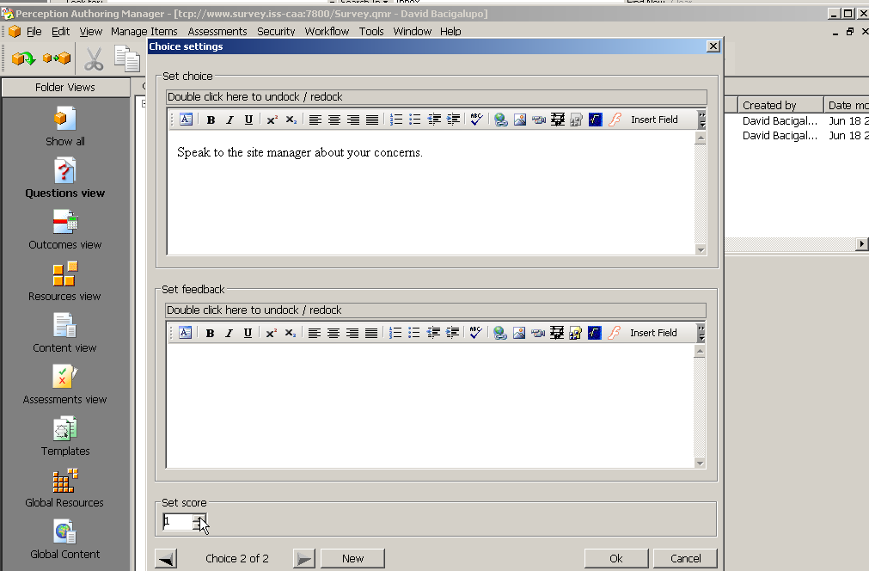

The author uses Questionmark Perception to create an eAssessment in the normal manner. For example using Perception Authoring Manager:

- In Questions View create questions using question wizard
- In Assessments View create “Quiz” assessment type using assessment wizard
- In the assessment wizard set the “display feedback” and “record answers in the answer database” options on screen 3 of the wizard.
- In the assessment wizard the assessment is made more accessible by selecting the appropriate accessibility template on screen 3 of the wizard

2.2. Users do eAssessment and Get Feedback

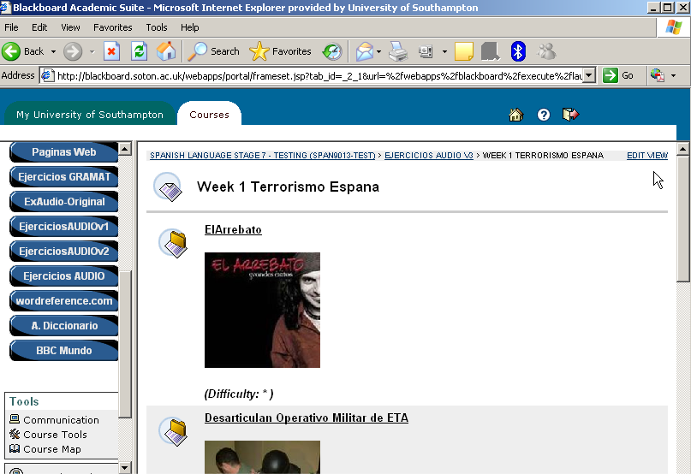

- The students access the eAssessment from the course virtual learning environment (Blackboard) by clicking on the link on the menu bar (shown in a black circle above).
- We recommend using images in the Blackboard pages to help encourage the students to do the eAssessment.
- The eAssessments are inserted into Blackboard as external web links

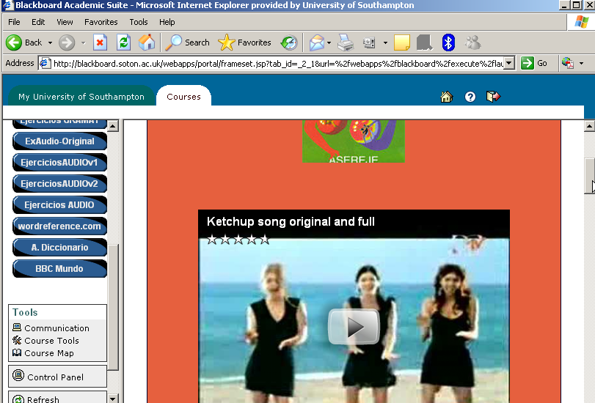

- An example of doing an eAssessment involving viewing externally hosted media files e.g. watching a video clip in Spanish from YouTube first, as in the above example

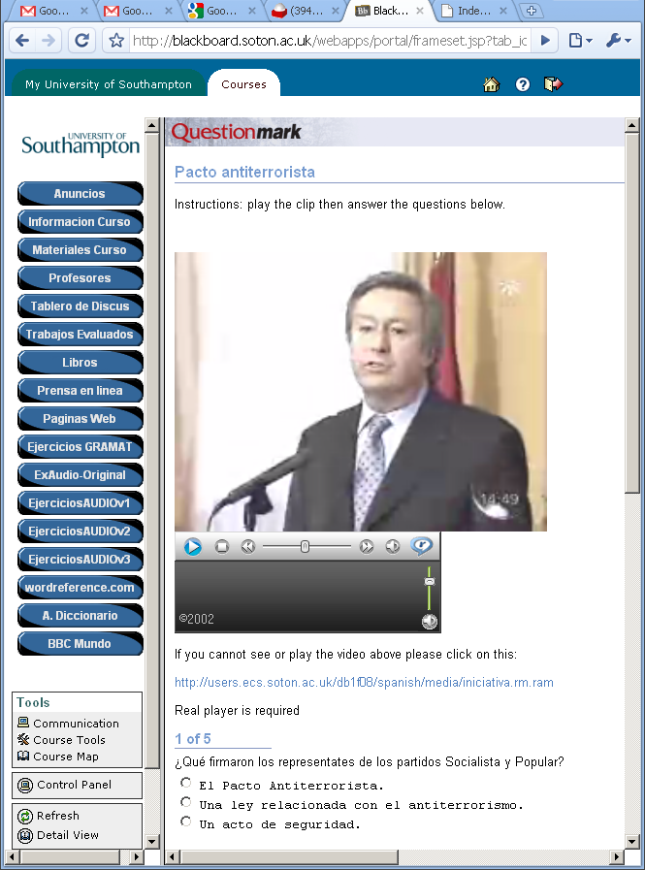

- An example of doing an eAssessment which requires viewing media hosted at Southampton, for example watching a short news clip first as in the above Spanish screenshot.
- Note: we have found that care must be taken to make sure that a video file is in a format that can be played on most web browsers.

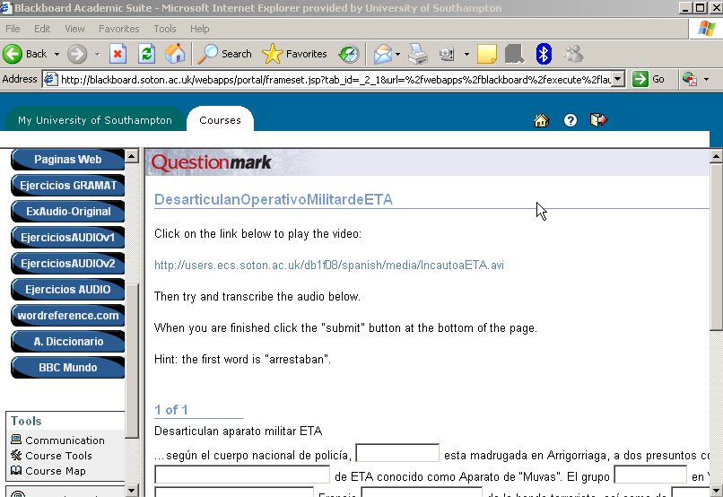

- An example of doing an eAssessment that involves fill in gap questions, in which the student has to transcribe the Spanish video clip he/she has just watched.
- Note: we have found that the Perception fill-in-the-gap functionality is not as rich as that from other products e.g. hot potatoes.

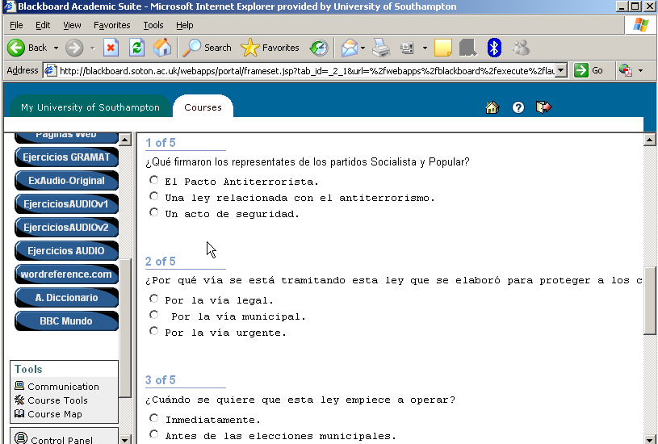

- An example of doing an eAssessment and answering multiple choice questions, in which the student has to answer questions about the Spanish news clip he/she has just watched.

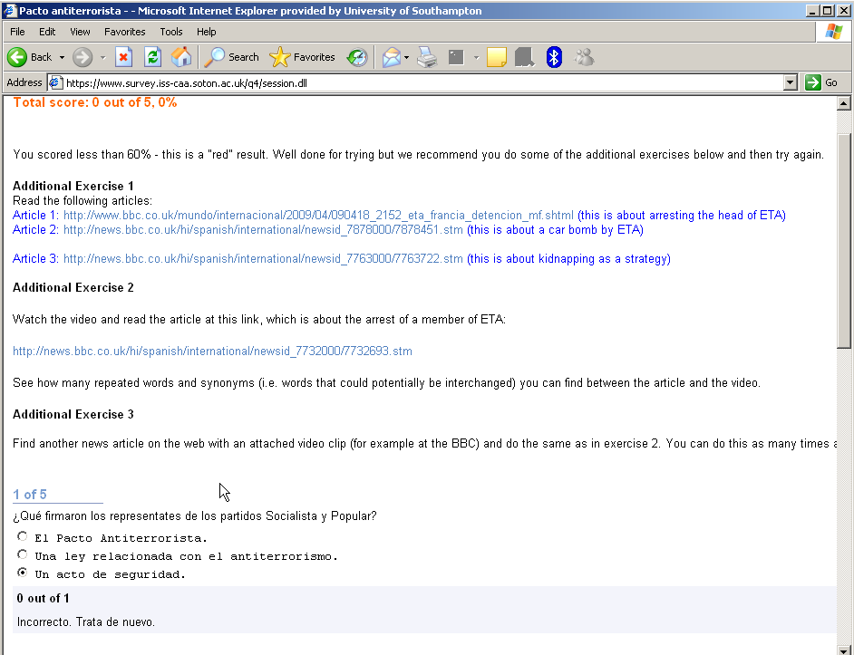

- After the student has finished the eAssessment he/she gets immediate feedback.
- As in the above example, this can be both per-question and per-eAssessment and vary depending on how well the student did on the question/eAssessment respectively.
- The feedback helps guide the students’ learning, as illustrated above.
- The feedback can include new exercises for the student to do, as in the above example.
- The feedback can encourage the student to create their own exercises to help them learn, as in the above example.

2.3. Author Generates Report on How Well the Users are Doing on the Perception eAssessments

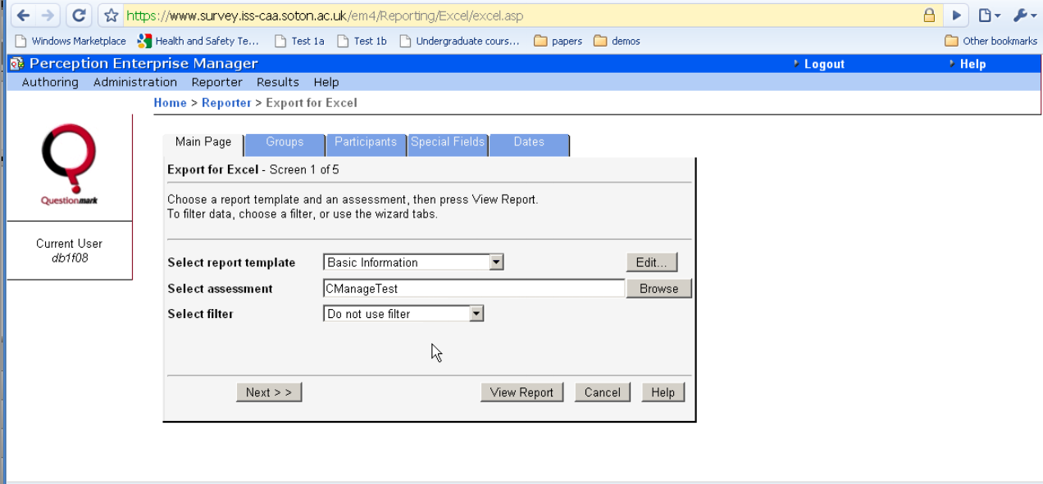

- The author generates a report on how students have done using the standard Perception functionality

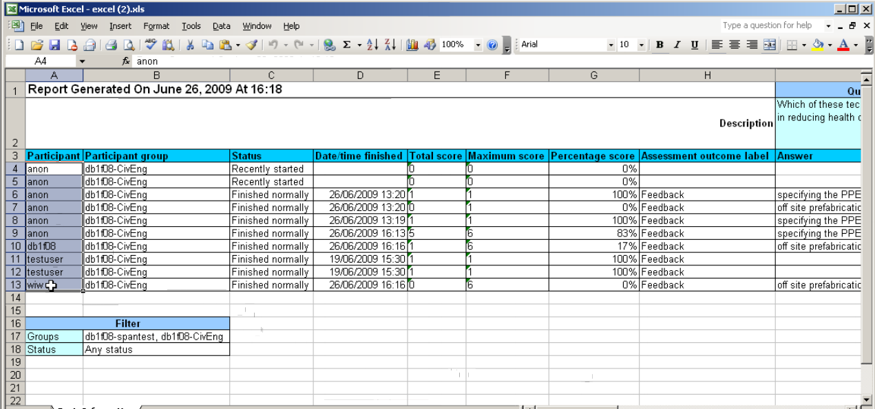

- The above is an example (from Civil Engineering) of the report on how well the students are doing, which the author can use to help guide the teaching.

3. Making eAssessments More Accessible

- Students can use the ECS study bar (also known as the JISC TechDis ToolBar) to change how eAssessments look e.g. to make it more accessible for students with AER. (The JISC TechDis Toolbar is continuing to be developed).

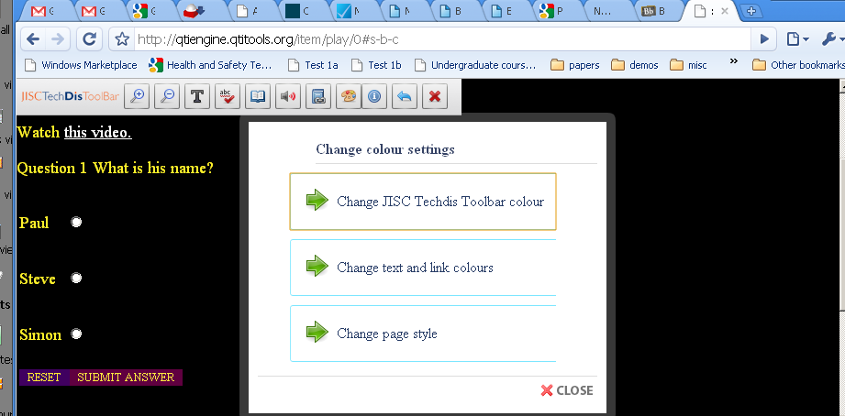

- Screenshot (from Bournemouth and Poole College case study)
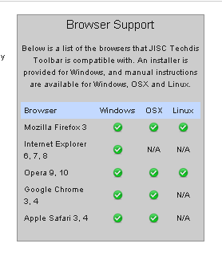
- See http://access.ecs.soton.ac.uk/ToolBar/
- Lite version available that doesn’t require installation

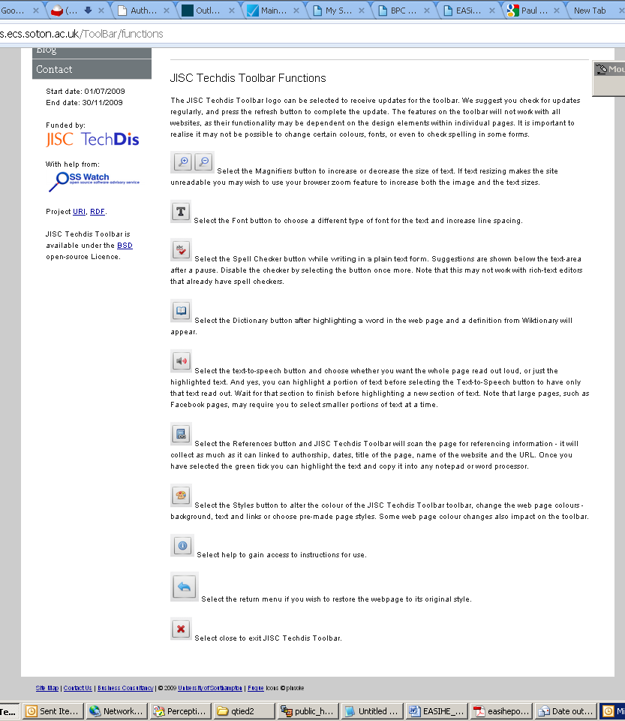

- Screenshot of documentation

4. Hot Potatoes eAssessments
- We have also examined alternative eAssessment systems to Perception e.g. Hot Potatoes as in the below example.
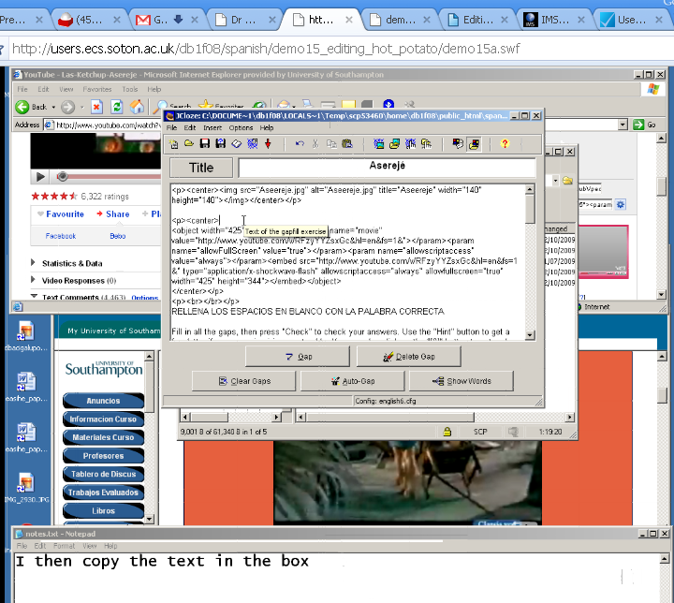
- Hot potatoes: simplified editing of the eAssessment

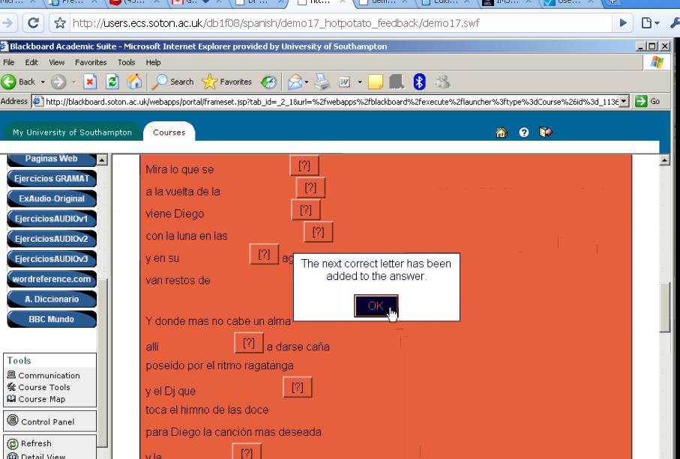

- Hot potatoes: doing the eAssessment (a fill in the gaps eg for which hot potatoes has a rich feature set )

5. Other Information
- There are aprox 10 eAssessments in the system
Part 3: The Solution: Advanced Functionality

1. Introduction
Figure 1 gives an overview of our software co-design for formative eAssessment for our case studies. The implementation of this is described throughout the rest of part 3. For each item of functionality one of the six EASiHE case studies is used as an example for the screenshot.

2. User Feedback and QTI

2.1. Users as “Web 2.0” can help the Author by Leaving Comments and Rating the eAssessment
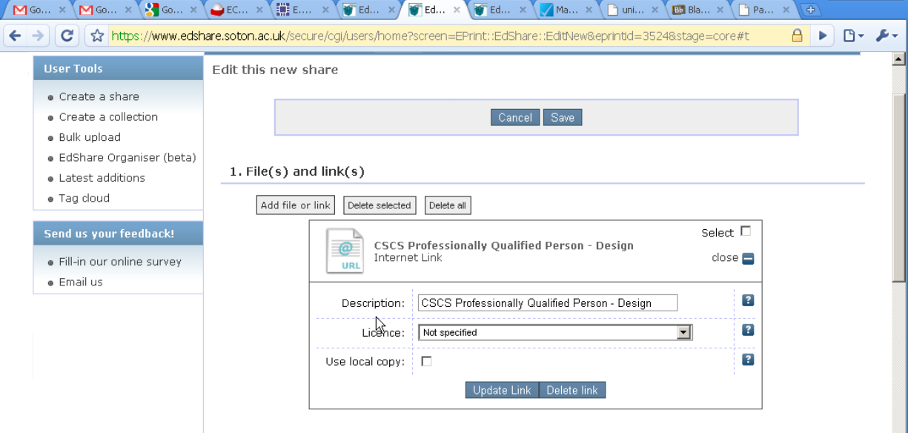

- A “web 2.0” EdShare page can be created for each eAssessment (e.g. linked to from the VLE);

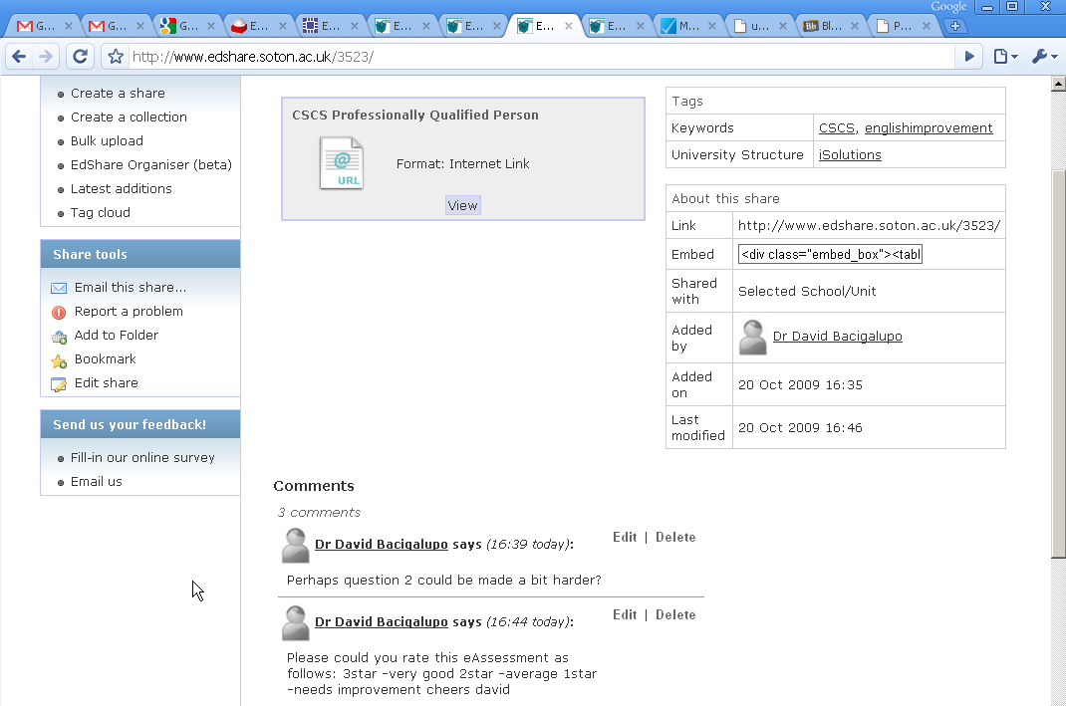

- The example above shows an EdShare page with a web link to a Perception eAssessment.
- Students can use this page to add text on how good a question was and to rate it

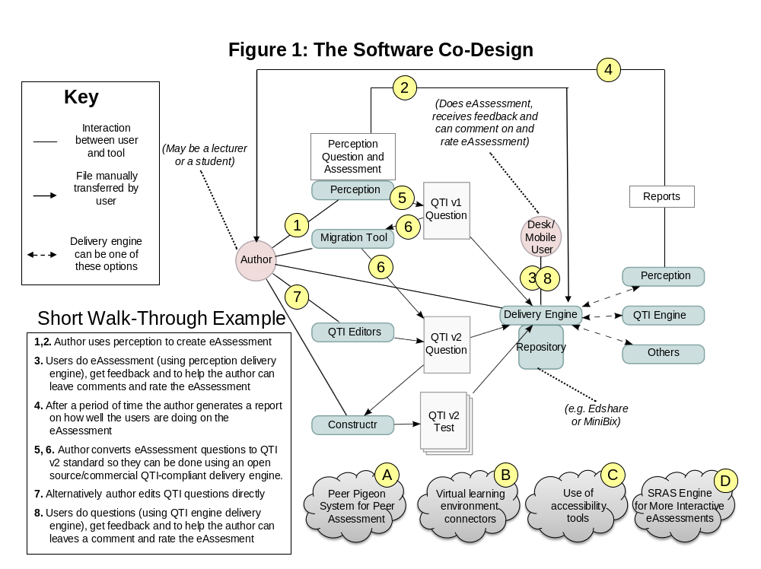

2.2. Author converts eAssessment Questions to QTI v2 standard

This is done so the eAssessment questions can be done using an open source/commercial QTI (Question Test Interoperability) delivery engine, and so it can be done on (currently just Android using a subset of QTI) mobile phones without a network connection. (Whereas Perception eAssessments require commercial software to run and although they can be done on a mobile phone, require a network connection to do this.)

- In Perception click on “Manage Items” then “Export” then “Export QTI XML”, type in a filename and click save. This is a QTI v1 file (the old version).

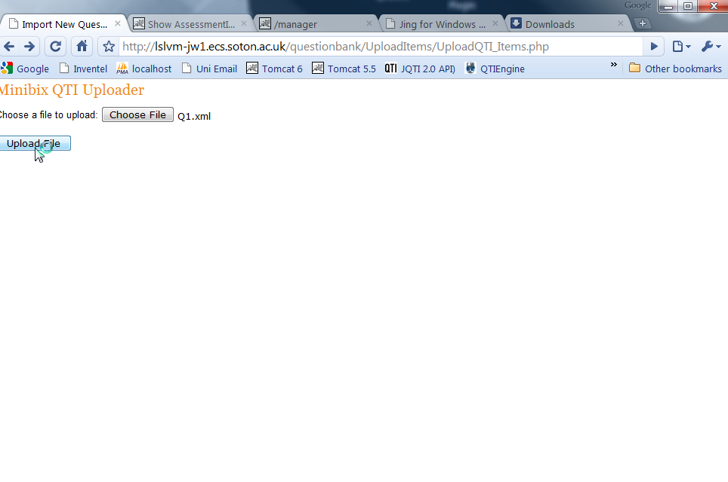

- On the MiniBix QTI Uploader page click on “Choose File” and select the QTI file exported from Perception. Click on “Upload file”.
- This converts the file to QTI 2.0 format and uploads it to the MiniBix repository in a 1-step process. (We note that as with many multi-stage editing and conversion processes creating the QTI in this indirect way is likely to lead to more verbose QTI than could be created directly. This can create a problem for tools that use this QTI, especially for question types other than multiple choice and multiple response)

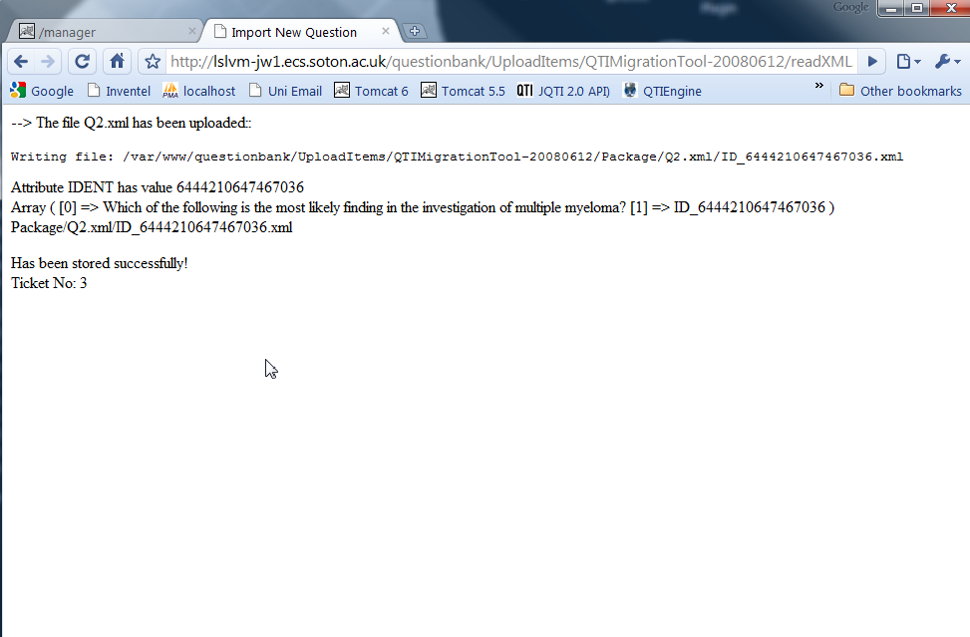

- The QTI v2 file is now in the MiniBix repository as indicated by the above screen
- Note: this process has not yet been tested e.g. there is a bug with this process that has not yet been fixed - sometimes the metadata file can overwrite the QTI file. However if there are problems this conversion and upload process can be done manually using the QTI v1 to v2 migration tool and a repository GUI in a relatively straightforward manner.

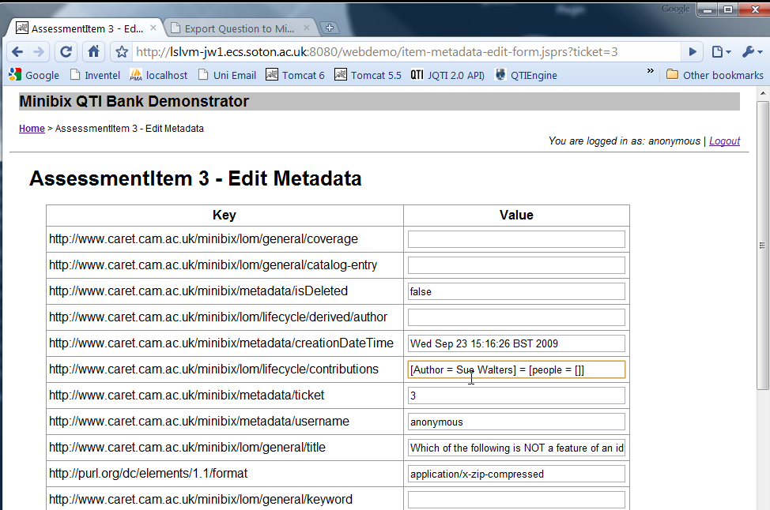

- The author edits the metadata in the MiniBix repository to make the QTI file easier to find again. (Currently the system creates a set of dummy metadata by default)
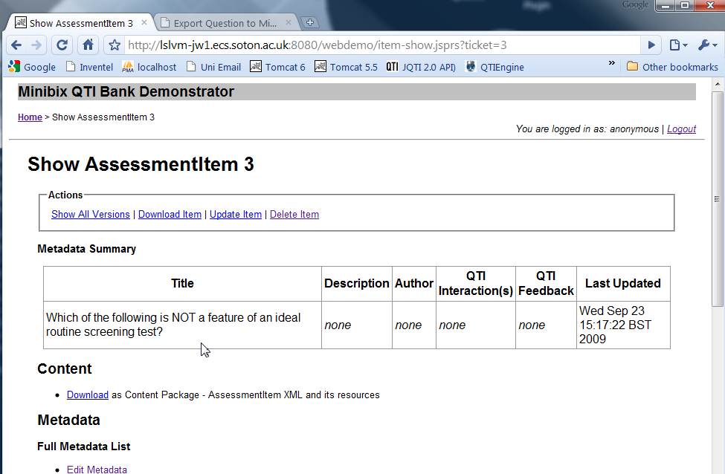

- The above screenshot shows the eAssessment meta data in the repository

2.3. Users do eAssessment (using QTI engine delivery engine)
- This example shows eAssessments in QTI v2 format being done by a user using the QTI Engine delivery engine. This example shows the mobile version of the QTI Engine on the Android mobile phone emulator (in debug mode) which does not require a network connection

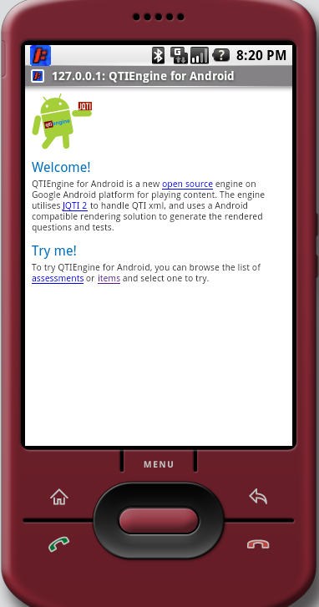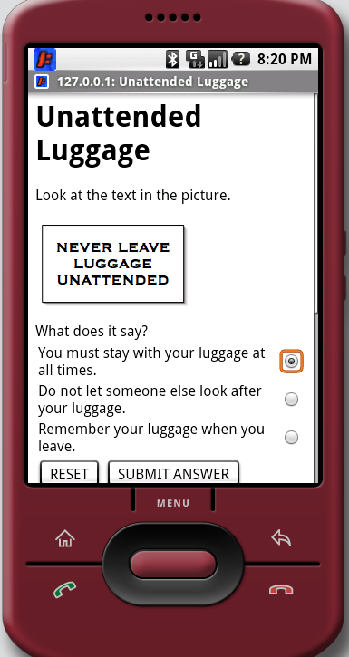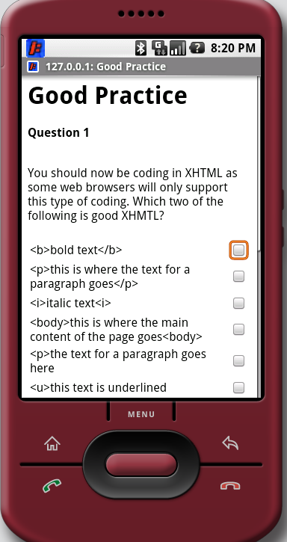
- Top row: welcome screen, example of multiple choice and example of multiple response
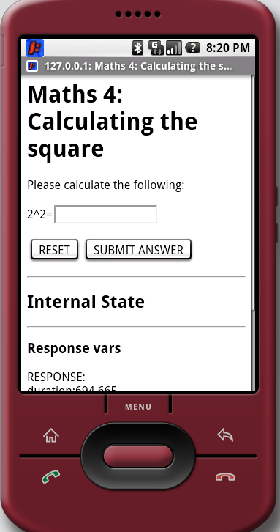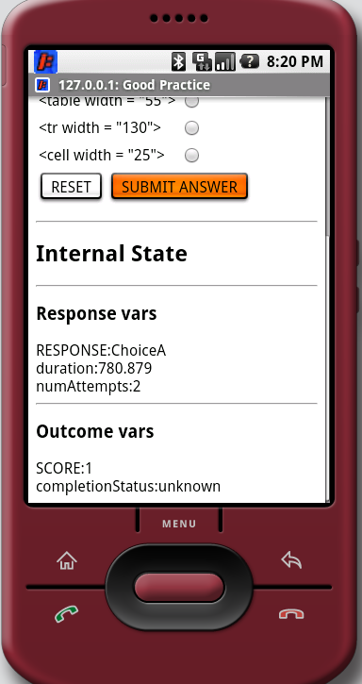
- Bottom row: example of text response box, example of debug information from tool
- We have also developed a mobile-focused QTI Editor to support this.
- We currently support a subset of QTI that in our experience authors are likely to use, and are focusing on the Android mobile phone platform.

3. The EASiHE Repository and QTI Editors

3.1. The Repository

- We have replaced the MiniBix repository with the EdShare repository.
- EdShare is a free, user-generated, education and curriculum resource that allows you to:
  - post eAssessments, other exercises, video and audio files, notes, worksheets etc
  - download high quality lesson plans, worksheets and materials that match the specific objectives you are teaching
  - help new lecturers survive through their first few years of teaching by allowing them to use your outstanding lesson plans and materials
- This is where we are storing both the BPC eAssessment questions and also the video files associated with them.

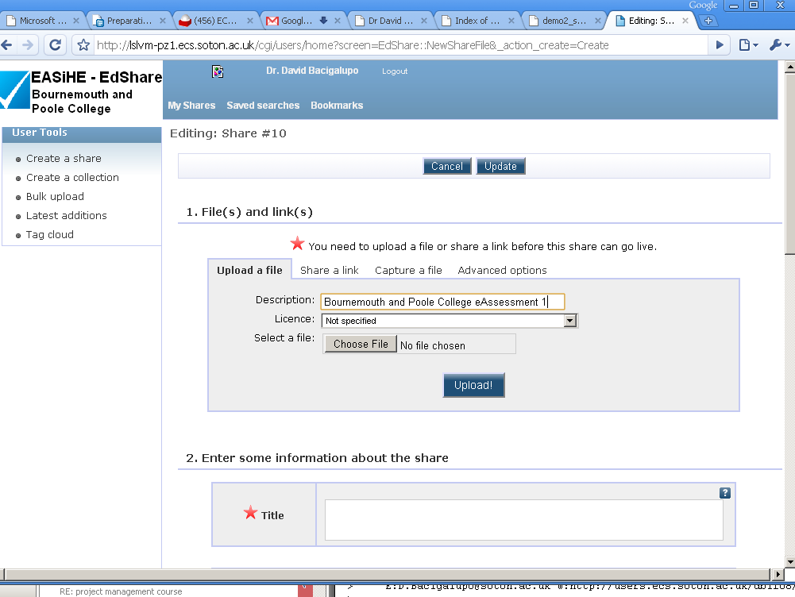

- Create a share

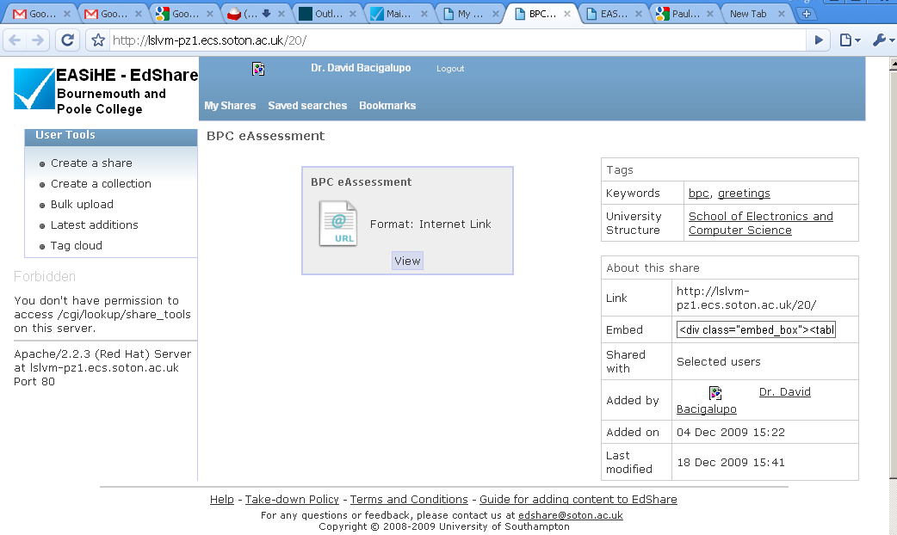

- View the share

3.2. Editing the eAssessment Questions

- The following screenshots show our web-based QTI question editor Eqiat to make it straightforward for anyone to create and edit QTI eAssessments questions.

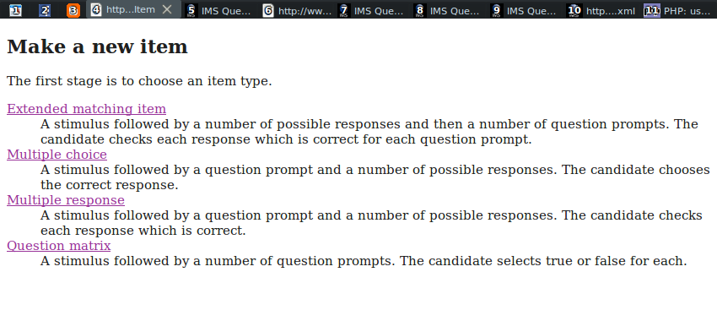

- Opening page

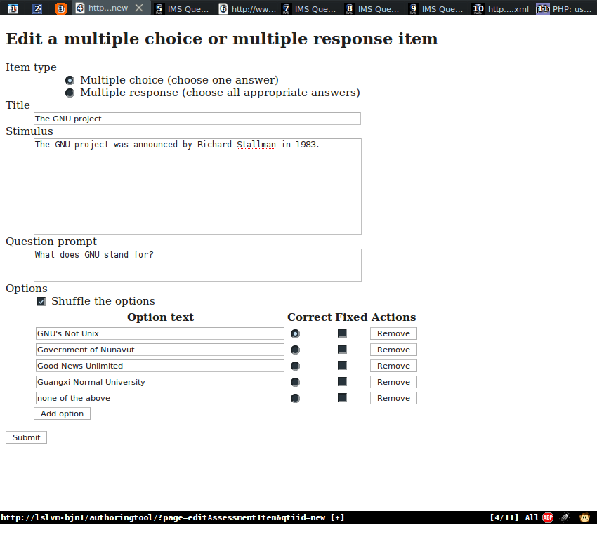

- Multiple choice or multiple response item authoring page

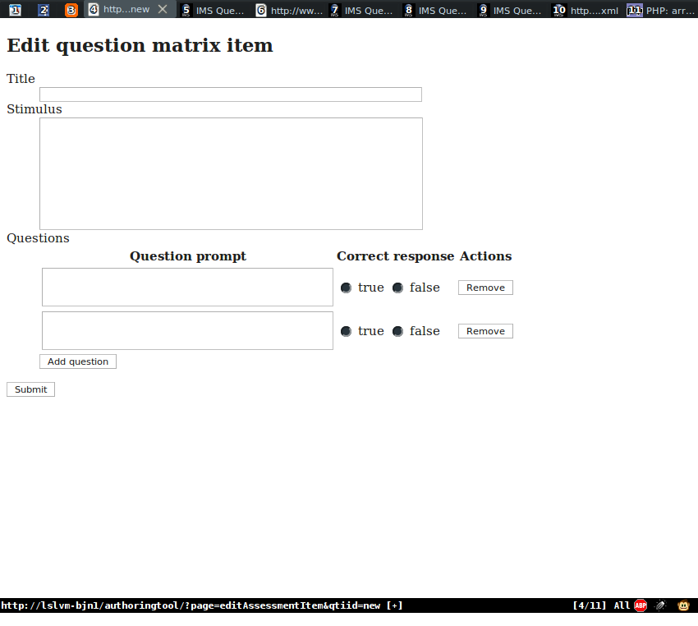

- Question matrix item authoring page

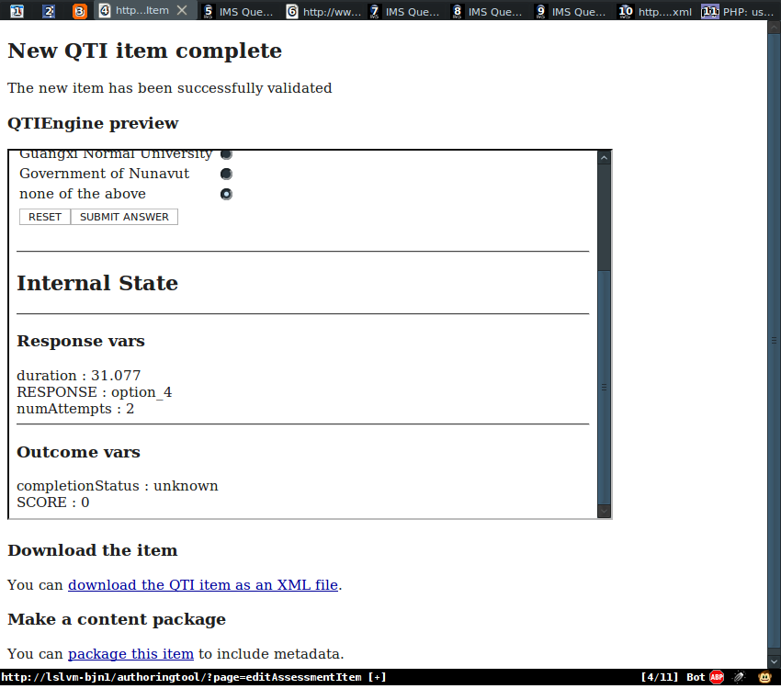

- Example of preview/download/create content package page

- Our web-based QTI authoring tool supports the following items:
  - multiple choice
  - multiple response
  - extended matching item (multiple multiple response with a common stimulus and list of options)
  - question matrix (multiple true or false) items.
- The items can be:
  - downloaded as XML files or
  - content packages.

- The following screenshots show our mobile-optimised QTI editor to make it straightforward for anyone to create and edit QTI eAssessments to run on a mobile.

3.3. Mobile-Optimised eAssessment Question Editing

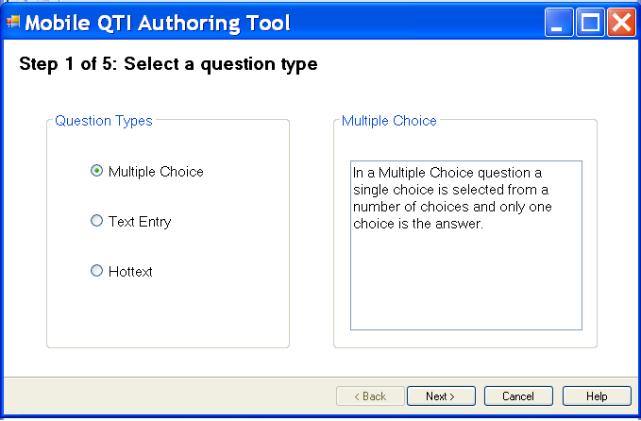

- This screenshot shows the select eAssessment question type screen

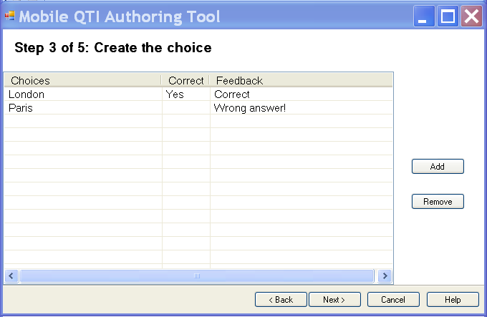

- This screenshot shows the screen for creating choices for the eAssessment question

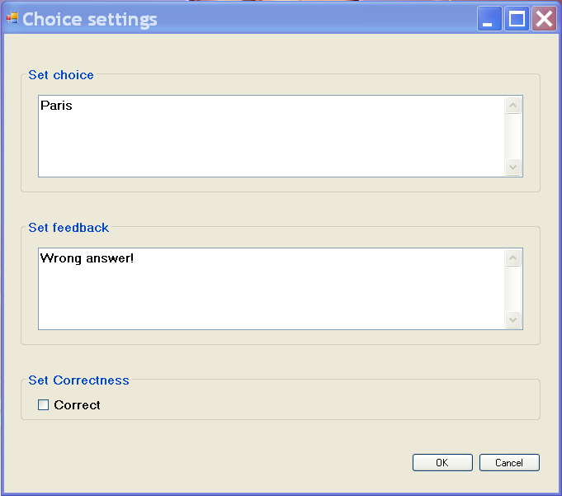

This screenshot shows the screen for editing a choice

Part 4: Further Information

1. Further Information about this Case Study
For more information and many screencasts please refer to the following webpage.

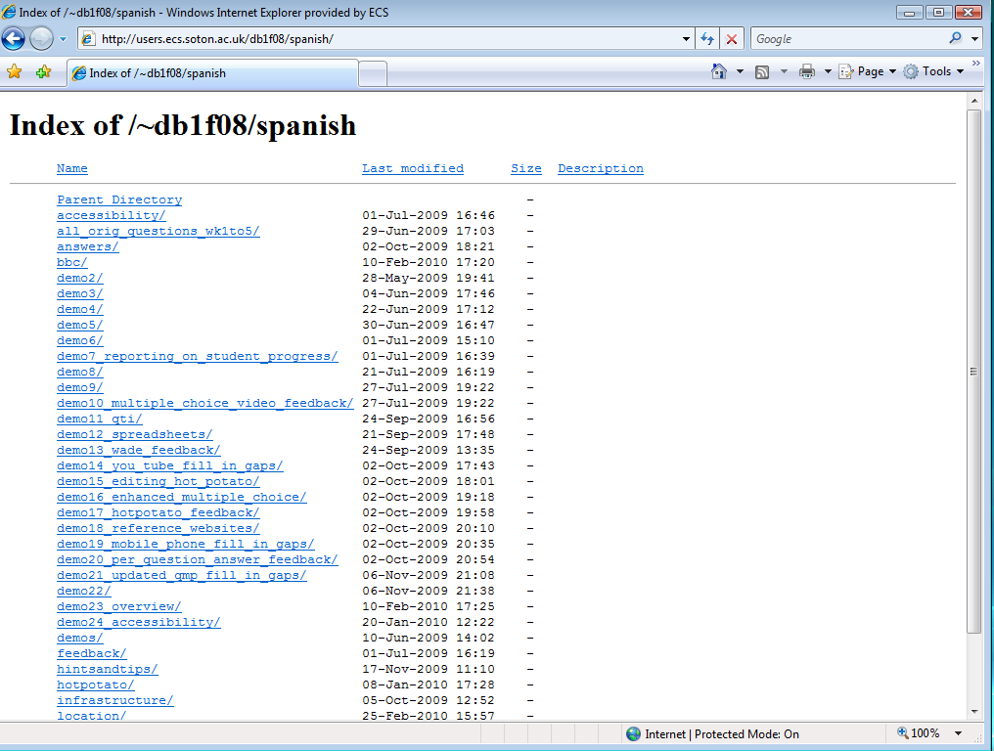

To get started using this archive we suggest you look at some of the following material.

Material | Webpage Folder/s | Reference from Figure 1 if Appropriate
Overview screencast | final_version | 3
Co-design personas and scenarios | personas_scenarios
Accessibility screencast | demo24 | C
Reporting | Demo7 | 4
QTI migration | demo11 | 5,6
Feedback to students | feedback
eAssessment video and audio files | media
Links to the eAssessments | location | 3

The majority of the remaining folders document chronologically how the final system was created.

3. Extended Version of Parts 2 and 3 of this Document
- Important note: parts 2 and 3 of this document described only selected features
- The case study details document on the EASIHE website is the full version

4. The EASiHE Website
For further information please refer to the EASIHE website:

- http://easihe.ecs.soton.ac.uk/

Part 5: Implementation Notes
- It would be helpful for a decision to be made as to whether to use Hot potatoes or Perception for the fill in the gaps (as opposed to multiple choice) questions.
  - At the moment a mixture is used so a comparison can be made.
  - It would also be helpful for a decision to be made for the week 5 eAssessment format which is currently a link to a BBC eAssessment so a comparison can be made.
  - Once this is decision is implemented the fill in the gaps questions could be more comprehensively tested
  - Once this decision is made the “out of hierarchy links” within blackboard could be removed as this could be confusing to students. These are currently there due to the presence of four earlier versions of the work documenting the iterative development of the system.
- Can some of the older video codecs be played by students without installing new software?
  - Can the university do a mass convert to flash format? Would this be useful?
  - At present some of the videos in older formats have to be popped up into a new window to play them whereas we would prefer that they should play in the embedded box.

Minor notes
- The system uses different options for different eAssessments for comparison purposes.
- Each link to an eAssessments is contained in an otherwise largely blank blackboard page. This is deliberate so teaching staff can make notes about the eAssessment on this page.
- The system uses two techniques to provide per-eAssessment recommended reading and associated exercises in the eAssessment feedback.
  - The first is to provide the reading and associated exercises along with the mark - this has the advantage the student cannot miss it.
  - The second is to provide it in a separate html document linked to from blackboard – this has the advantage that when the per-eAssessment reading and associated exercises is duplicated between multiple eAssessments (as is common); there is just one easy-to-find document to be updated.
- The system relies on the URLs to the School of Humanities videos and some of the external website links not changing; if they are changed the videos/external links won’t work.

