Comparison of OPM and Karma3 models
Provenance of document:
V0.1 June 08, 2008, Abhijit Bourde
V0.2 June 10, 2008, Beth Plale
V0.3 June 13, 2008, Yogesh Simmhan
V0.4 June 19, 2008, Beth Plale – reflects discussion at OPM Workshop Jun 19, Salt Lake City

Karma3 is a workflow provenance collection framework currently under development at Indiana University. This document is intended to explain how current version of Karma is compliant with Open Provenance Model (OPM). Compatibility with OPM is important to ensure that Karma is based on accepted standard and is able to exchange information with other provenance tools. Three most important aspects of OPM are entities, dependencies between entities and provenance graph.
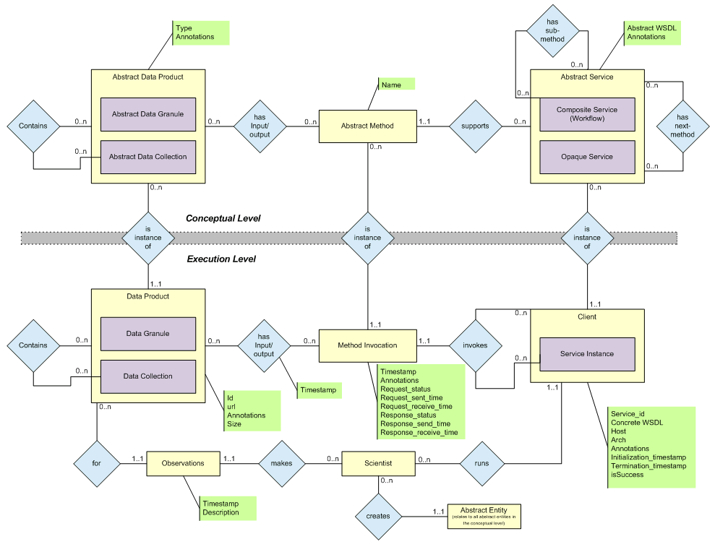

Figure 1: Karma3 Data model

1. Entities:
OPM defines three primary entities- Artifacts which are immutable piece of state, Processes which are actions or series of actions performed on or caused by artifacts and Agents which are contextual entities that act as a catalyst of a process. Karma3 has the following entities mapped to OPM entities as follows:
Artifacts:
- Data Granule and Data Collection
- INTEROP: OPM does not seem to support the idea of granularity for data products
- OPM Workshop notes: general support for some handling of collections. Artifacts are snapshots of state. Artifacts have unique global IDs, but the ID does not necessarily map to, say, an LSID.
Process:
- Composite Service and Atomic Service
  - Service has methods
  - INTEROP: OPM appears to support the idea of service/workflow composition using Alternate Accounts
- Karma “used edge” generated by Abstract Method object and not Service Instance
  - INTEROP: It is possible to infer that an edge from a method to/from a method means that there is an edge to/from the service that contains this method. Likewise for service that are contained within a workflow. So Karma indirectly supports to/from methods from service/workflows
- OPM Workshop notes: introduce subclassing, where subclass is of a known pattern that provides some clue on its functional behavior.
Controller:
- Karma has Scientist and Client
  - INTEROP: The “Client” may be a service instance or a process that initiates the “Workflow”. In the latter case, the Client acts as a “digital proxy agent” for the scientist and fits the role of an OPM Agent. An example of a Client is the Workflow Engine that orchestrates the Workflow. However, a Client can also be considered to be the initiator of the Workflow. So we can essentially model an OPM Agent (Scientist) and a proxy for that Agent (Client).
  - We model a “Client” in Karma as the source entity during a transition between two execution levels (a client and a service) and this can cause an overloaded interpretation.
    - A service that invokes an external workflow/service acts as a client to the external workflow/service
      - The service can either be acting as a proxy for a scientist or as a component in a workflow
    - A workflow engine that invokes a service as part of a workflow execution acts as a client to that service.
  - OPM Workshop notes: ‘agent’ term dropped from OPM. Most important piece is the ‘WasControlledBy’ edge.

2. Dependencies:
OPM defines following five types of causal dependencies
Type 1. Process used artifact
Type 2. Artifact was generated by a Process
Type 3. Process was triggered by another process
Type 4. Artifact was generated by another artifact
Type 5. Process was controlled by agent

These causality edges use the past tense referring to an execution that has completed. Karma has following causal dependencies whose mapping to OPM:

- Method invocation <has input> data granule/collection (Type 1)
- Data granule/collection <Inverse(has output)> method invocation (Type 2)
- Abstract service <has next method> another abstract service (Type 3)
  - Composite service <has sub method> another abstract service (Type 3)
- Data granule 2 <inverse(has output)> method invocation <has input> data granule 1 (Type 4)
- Service instance <Inverse(runs) > scientist (Type 5)
  - Service Instance <Inverse(invokes)> Client

3. Inferences

Karma supports all the inferences defined since we support all the edge types.

4. Concepts With Non-aligned Overlap
1. Roles. Roles further qualify a predicate/relation with parameters. These are not supported by current Karma3 relations, though extension through adding attributes to Karma3 info model could easily be done.
2. Alternate accounts. Alternate account in current version of OPM document is one of overlapping accounts. Additional refinement suggested in meeting is to support composition. Karma has abstract and concrete representations. Composition is an important concept in Karma.
NOTE: <Has Sub-Method> enables workflows composed out of services. This fits the alternate account example of providing “different levels of abstraction”. Karma does not, however, directly support different viewpoint in the Karma model. One type of differing viewpoint that we support as an artifact of our implementation is the client and service accounts of provenance. Since the client and the service generate provenance events independently, these form two different viewpoints. However, in the model, we only present an integrated view and do not define a way of recording both viewpoints (one of the views “wins” in case of conflict).
Abstract representation is useful addition to Karma, particularly in representing partial semantic information. Abstract information may be used to help flesh out exported OPM provenance graph.
3. The OPM graph. Not specifically represented in Karma, but can be properly constructed.
4. Time. In OPM, all observed times are pairs of instantaneous time values. Note that time is an attribute of edges – see Figure 12. Karma supports either a logical time or a physical (timestamp) time and assigns instantaneous time values to entities and not edges. Karma does tie time to an edge in one case: it captures the begin and end time of a data transfer. But this edge may not be well represented in Karma3.
The Karma abstract notion of time is not limited by granularity, accuracy or timezone issues. This is “better” than the OPM definition of absolute times as it helps make more accurate assertions than absolute time. We also support wall clock time for user interpretation.
Additional OPM Workshop Notes: The model attempted to leave the specification of a specific time system open, and specify only time’s relationships to model entities and relationships. There was a long discussion on the long lived process that generates artifacts through its lifetime. OPM graphs should be viewed as monotonically increasing.

