26-27 January 2012
University of Southampton
Avenue campus

E-learning Symposium 2012

Abstracts

Supported by
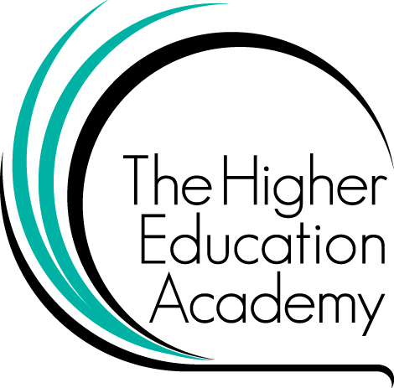

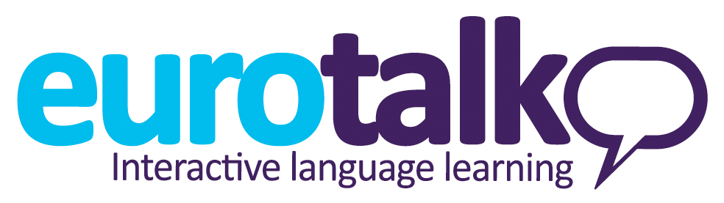
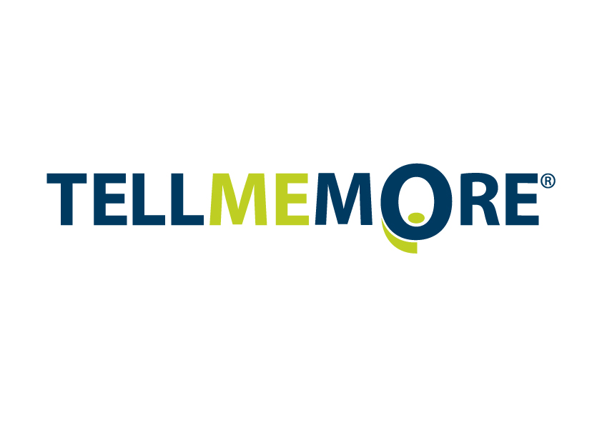
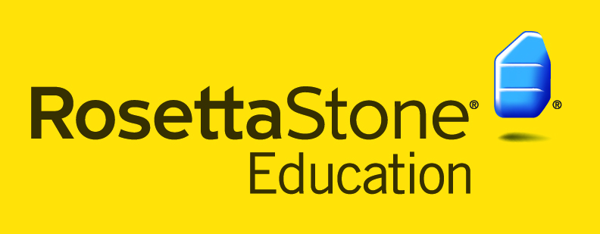
Abstracts
Keynote speakers

Tweeting and teaching: how scholarly is social media?

Claire Warwick, Professor of Digital Humanities; Head of the Department of Information Studies at University College London; Director of the UCL Centre for Digital Humanities; and Vice-Dean for Research for the Faculty of Arts and Humanities

Social media applications are often dismissed by academics as gossip-platforms on which our students share pictures of themselves or talk about anything except learning. There seems to be a widespread view that nothing serious or scholars could possibly be said in 140 characters, and that crowdsourcing cannot possible be used to address real research problems. I shall ague that if we make these assumptions then we under-estimate the potential of social media and crowdsourcing to advance research and learning both online and in the physical world. I shall discuss research being done with social media UCLDH: on crowdsourcing transcription of Jeremy Bentham’s papers and on the interpretation of objects at UCL’s Grant Museum and the Imperial War Museum. I’ll also discuss the recent global twitter phenomenon #tweetyourthesis which began at UCLDH and allows research students all over the world to share their research ideas- in 140 characters. I shall maintain that rather than simply being channels for pointless chatter, social media have to potential to offer new ways to us to interact, to do research, to learn and to communicate with the public beyond academia.

Language Teaching in Blended Contexts

Margaret Southgate, Senior Lecturer and Staff Tutor in Languages, Faculty of Education and Language Studies, The Open University in Wales

The ever-evolving field of elearning presents language teachers with a multiplicity of opportunities and challenges. This presentation will draw both on research findings and on the practical experience of Open University language teachers who have successfully combined conventional face-to-face and telephone teaching with a range of synchronous and asynchronous online teaching modes. The affordances of various tools and resources will be discussed, considering how they can best be integrated into a coherent whole, rather than as a number of unconnected elements or optional extras. The presentation will consider the changing role of the teacher in providing appropriate support for a diverse group of learners in blended settings, and will give some practical examples to demonstrate how teachers themselves can be supported through the use of a similar blend of tools and resources in a teacher development programme.

Enhancing student engagement and motivation through games-based learning

Mark Stansfield, Reader in Learning Technologies at the University of the West of Scotland.

This presentation will explore the contribution that games based learning can provide in relation to enhancing learner motivation and engagement. Games based learning has the potential to provide stimulating and enriching learning content and experiences for students at all levels. Such technologies are considered to be particularly suited to motivating the younger generation of learners who have grown up in a technology rich environment. An example of an Alternate Reality Game (ARG) will be given that was developed which aimed at increasing the motivations of secondary school level pupils across Europe in the learning of modern foreign languages. An ARG is a form of narrative often involving multiple media and gaming elements to tell a story that might be affected by participants’ actions. The collaborative nature of ARGs provides a potentially useful vehicle for developing collaborative activities within an educational context.

The presentation will provide some of the main advantages, barriers and issues associated with using games based learning within Higher Education, as well as providing some further examples of games to illustrate points. The final part of the presentation will look at emerging and future trends in the area and how they might relate to Higher Education.

Abstracts
Speakers at the elearning symposium 2012

Apps for mobile learning: from theory to real world application

Caroline Moore, Director Constellata Limited and Co-Founder of LearnAhead Ltd.
www.constellata.com and www.learnahead.co.uk

There has been an explosion globally in the use of smartphones used by their owners on the move to access information and entertainment.

The mobile phone application, or app, has enormous potential for language learning. Apps allow for multisensory learning, for learners to use nuggets of time in a queue or on public transport. Tablet devices are beginning to serve as classroom substitutes for textbooks.

The presentation reports on an ongoing research project which began in late 2010 with a survey of 100 apps published internationally for learners of English and other modern foreign languages. They liked some of the features they found, such as the ability to personalise learning, and scoring and tracking routines. Their list of negative attributes is longer: too many translations, not enough sound or pictures, ugly and pointless flashcard apps, and reference books dumped into apps. There was over-reliance on multiple choice and true/false questions. Overall there was insufficient exploitation of the smartphone’s “superpowers” such as its touch screen, motion sensors, location detector, calendar notification and connections with other users.

The research now includes a wider range of devices and contexts and the researchers are developing frameworks that help publishers and course providers offer real educational value to language learners.

The presenter will discuss recent personal experience of developing materials for two mobile app projects. The first is an arcade iPhone vocab game app designed to help A1 learners of English. The team have worked to develop an engaging game, based on sound pedagogical principles with an intuitive user interface. The second is a highly ambitious project to adapt existing Adobe Flash-based course materials originally designed for CDROM and web to mobile for A1 to B1 learners of English, French, Spanish and German.

Also discussed are the challenges that had to be overcome, including decisions about what technologies and platforms to adopt, copyright and intellectual property issues, and how to make such projects sustainable and commercially viable.

Rethinking the employability agenda in languages

Filippo Nereo, HEA Languages Discipline Lead, Honorary Lecturer in German Linguistics, University of Manchester

The new fees regime is likely to reinforce students’ consumerist attitudes towards Higher Education and lead to increased expectations of value-for-money and graduate employability. This is particularly the case in language disciplines, where four-year undergraduate programmes are the norm. All stakeholders in the ‘student experience’ – academics, but professional support staff too – therefore need to respond creatively and collaboratively to these pressures. Key to this challenge is the diversification of modes of delivery and assessment, and recognition that skills development must be positioned at the very core of the units we deliver. Moreover, we need to facilitate the transfer of new ideas on diversification between colleagues.

This paper reports on a unit aimed at students of German linguistics (although the design is transferable to other language disciplines), and developed in close liaison with colleagues in a University Careers Service and a Faculty eLearning Team. The unit begins with some introductory lectures setting out the structure of and rationale for the unit, and underlining the importance graduate employers attach to transferable skills as much as academic ability. The principal mode of delivery, however, is enquiry-based learning. Having identified linguistic aspects of the ‘awful German language’ (Mark Twain) that pose a real-life problem to foreign language learners, groups of students – closely guided by the facilitator – devote their time to developing their own e-tool, designed to address the learner needs they identified. Team members are required to communicate regularly with each other and with focus groups, whilst team leaders, who rotate on a weekly basis, are responsible for the delegation of tasks in accordance with their team members’ skill sets, the assignment of clear roles and responsibilities, and documentation of meetings.

Summative assessment of both subject knowledge and a range of key transferable skills takes three forms. First, students regularly submit reflective statements on the progress of their projects in response to prompt questions typically encountered in graduate interviews and application forms. Second, teams submit an end-of-project report, which details how the project performed against the aims and objectives set at the beginning of the semester, and reports on project-related risks identified by the students, ways in which they were mitigated, and lessons learned. Third, students present their projects in the form of an oral presentation and poster at an open session, which academic staff, as well as colleagues from the Careers Service and eLearning Team, attend. In this way, the students benefit from much richer feedback from an audience that is able to give different perspectives on the students’ work, and the session also offers a unique opportunity for staff to come together, and facilitates discussion on new approaches to unit delivery and assessment. Peer-reviewers, careers consultants, the external examiner, and students have commented positively on the unit, which has proved popular with students, with numbers doubling in one year.

ePresessional: a blended approach to delivering pre-sessional courses in EAP for international students

Julie Watson, Principal Teaching Fellow in elearning, and Steven White, e-tutor, University of Southampton

The ever-growing numbers of international students pursuing degree programmes at UK universities (UKCISA, 2011), has placed a severe strain on many summer Pre-sessional Courses in English for Academic Purposes. Taking advantage of technological affordances and prior experience in delivering tutored online degree programmes (Watson and Baker, 2011), at the University of Southampton an online pre-sessional course was developed and delivered to 65 international students in receipt of confirmed offers of places on MSc and MBA programmes in the School of Management. The students, who were required by the department to follow 15 weeks of EAP preparation, undertook the first five weeks of their pre-sessional online with a focus on academic writing and reading; study skills, vocabulary and grammar development. They produced weekly assignments and were tutored throughout the course by British EAP tutors. They then arrived in Southampton to complete a further ten weeks, face-to-face, on their pre-sessional programme.

This blended approach to pre-sessional provision has a number of benefits and may well also help prepare students for UK academic culture prior to their arrival. Student satisfaction levels were high and research is currently underway to establish whether students who follow online preparation courses of this kind reflect higher confidence levels on arrival than those who do not. The first part of this presentation will outline and demonstrate the online pre-sessional course. The second part will present the online pre-sessional from the tutor’s perspective. Finally some initial findings from the evaluation will be discussed.

References:

UKCISA (2011) International students in UK higher education: key statistics. Retrieved from http://www.ukcisa.org.uk/about/statistics_he.php

Watson, J. and W. Baker (2011) Mastering the online Master’s: the repurposing, delivery and evaluation of an online Master’s degree programme (Forthcoming)

Technological diversity: an investigation into language learners' technology use inside and outside the classroom

Billy Brick, Language Centre Manager and Tiziana Cervi-Wilson, Dept of English and Languages, Coventry University

The speed of technological advance in smart phone and tablet market has meant that learners increasingly have access to devices capable of enhancing their learning experience. These devices have the potential to change the delivery of teaching and learning in higher education. This paper reports on a study aimed to investigate how language learners, taking Italian as an option on the University Wide Languages Programme (UWLP) at Coventry University, use their smart phones and other digital devices to support their language learning. Approximately 200 learners taking Italian at levels 1, 2 and 3 were asked to complete an on-line questionnaire. The first section of the questionnaire asked learners to indicate the devices to which they had access. The second section then aimed to gain and understanding of the frequency with which they used their devices inside and outside the classroom to support their language learning. To capture more in depth data referring to specific usage of their devices in the four skills: reading; writing; speaking and listening; several questions based on the five point Likert scale were asked. Finally, learners were asked to explain how they used their devices to access dictionaries and thesauruses. To triangulate the study semi-structured interviews were carried out with a sample of the participants.

Publication and collaboration: publishing open research data and creating teaching resources for the OpenLIVES project

Alicia Pozo-Gutierrez, Lecturer in Spanish and Portuguese, and Irina Nelson, Lecturer in Spanish, University of Southampton

This presentation will introduce the work of the JISC-funded OpenLIVES project, a current collaboration between the Universities of Southampton, Leeds and Portsmouth. This project seeks to link research and teaching in innovative and practical ways by publishing a set of primary research data as open content for others to access and re-use, and then by creating sets of open educational resources related to this data.

The research data used in this project documents the experiences of Spanish migrants to the UK and returning migrants to Spain. Oral testimonies, images and other ephemera have been collected by researchers at the University of Southampton and will be used by all project partners to create resources for teaching and learning. This presentation will outline the challenges and issues in making primary data open for re-use by others, and describe the varied ways in which tutors at each institution will interpret the materials and embed them into their work. It will outline the benefits of open sharing and collaboration in research and teaching, and indicate practical ways to involve students in the use of primary research and the creation of open content as part of their studies.

Language Learning in the Virtual World of English City: Using LanguageLab.com to Support International Learner Identity

Michael Thomas, Senior Lecturer in Language Learning Technologies, University of Central Lancashire

An increasing amount of research on immersive 3D virtual worlds in language education suggests that they may provide opportunities for learners to engage in authentic language use and collaborative communicative tasks. Furthermore, as an alternative to video conferencing or asynchronous technologies, the use of an embodied learning environment in which learners can manipulate an avatar version of themselves may present language learners with opportunities to improve various aspects of their L2 learner identity. Given the wider context of the visa restrictions from the UK BA on international students, this paper analyses preliminary data collected from a study of final year international students from China, France and Germany studying on an undergraduate degree in business English who are using a virtual world called EnglishCity provided by LanguageLab.com in Second Life.

The aim of the study was to examine the use of a task-based approach utilising an immersive virtual world to enhance learner identity in the target language. Research questions focused in particular on how virtual worlds can be used with international language learning students to promote learner equalisation and learner agency. Secondly, research focused on identifying the challenges faced by international language learners in studying online in terms of technical and digital literacy skills and intercultural communication. Data was collected for the case study based on field notes, computer screen recording, classroom video recording, semi-structured interviews and questionnaires. The project is due to conclude in April 2012 and this paper will present findings from the mid-way point of the study in the context of existing research on the subject.

The Online Discussion Board for Translation - An Undergraduate MFL Perspective for the Study of Italian and Russian

Andrea Zhok, Language Director, Italian, and Elena McNeilly, Language Teaching Fellow, Russian, University of Bristol

This paper explores the implications (pedagogical, practical, psychological, etc.) of adopting the Online Discussion Board facility offered by an institutional VLE (Blackboard) to develop autonomy and reflection in students studying translation within second year language units which are part of MFL degree courses at the University of Bristol. The paper focuses both on translation from the TL (Italian into English) and into the TL (English into Russian) and considers the advantages of embracing the use of electronic tools which bring real added value in a blended learning approach and initiate a culture change in participants’ teaching and learning practices.

The paper analyses the rationale and processes of moving from a tendentially prescriptive to a more descriptive, reflective and empowering approach in teaching translation which is made possible by asynchronous online interactions within a controlled learning community, and the changing role of the tutor as facilitator and mediator in a truly learner-centred environment (moving from a frontal and monodirectional model of teaching to a pluridirectional, communal dimension in which ‘authority’ is more fluidly managed amongst all participants).
The project also addresses issues related to assessment, as it aims to introduce gradual self and peer assessment techniques raising questions in terms of reviewing and challenging established institutional assessment practices.

Using a social networking site to facilitate tandem language and culture learning

Cathy Howard, Senior Tutor in the School of English and Languages, University of Surrey.

This presentation will review the experience of setting up and running a social networking site for the purposes of facilitating a tandem learning scheme, the Language and Culture Exchange Scheme (LACES), at the University of Surrey. The presentation will cover the background to LACES, its aims, the choice of social networking platform, and the experiences of its first year.

The scheme was set up in partial fulfilment of the University’s stated International Strategy aim of encouraging students to form “language and cultural learning partnerships”. The challenge was to develop an efficient mechanism to match students with potential language and culture exchange partners, and at the same time to promote and support autonomous language learning. The solution was an online environment, ring-fenced to Surrey students, which would enable them to identify and meet up with potential partners as well as access relevant materials and information to support them in improving their target language.

Sharing some of the features of an online “dating agency”, safety issues were a key concern and for this reason the ability to ring-fence the network to Surrey students was one of the key objectives. A number of social networking platforms were assessed and the eventual choice was Ning – a paid-for platform, which had the advantage that it could be run as a “closed” network, thus ensuring that only Surrey students could join. In the first year over 400 students, speaking more than 40 languages joined the scheme.

The presentation will provide a “walk-through” of the key features of the LACES network. It will also provide an analysis of both the intended and unintended benefits, as well as the difficulties encountered in the first year. Developments implemented in the second year will also be discussed. The network could easily be replicated in other HE institutions, the only pre-requisite being a large population of international students.

The Use of Technological Resources as Mechanisms to Facilitate Inter and Extra Classroom Interaction for Learners of Portuguese as an Additional Foreign Language

Mr. Antônio Márcio da Silva, Brazilian Lector, BirkBeck University of London and Dr. Lúcia Rottava, lecturer in Portuguese at Federal University of Rio Grande do Sul (UFRGS), Brazil.

The use of new technologies has increased interaction in the teaching and learning of languages and made this process more dynamic in that it enables learners to develop competence inter and extra classroom. Recent research (e.g. Blake 2008 and Catherall 2005) indicates that teaching practices contemplating the use of new technologies conceive virtual resources as mechanisms for connecting and expanding in-class tasks in many ways. As such, learners have the opportunity to expand the use of the foreign language in contexts beyond the classroom. In these, they interact not only with peers and the teacher but also with other users of the target language; in turn, these resources also allow the teacher to track the learners’ tasks to act as a facilitator in the learning process. In the case of part-time learners attending university evening courses, many of whom work in various branches of professional activities during the day, technological resources (e.g. Blackboard, Vocaroo and Jing) allow learners to develop tasks that will help them to maintain contact with the target language at their own convenience. Therefore, the aim of this presentation is to report possibilities of interaction that occurred in tasks performed beyond the classroom, in virtual learning environment, by learners of Portuguese as an additional foreign language who live in a multilingual context. The data derive from interactive oral and written productions. The results suggest that technological resources provide opportunities for learners to use the foreign language in different situations, explore topics of their own interest, exchange professional information, perform oral and written tasks according to individual availability and interest, and increase the time of interaction in the target language.

Using Social Media for peer-feedback in a translation class: a case-study

Benoît Guilbaud, Lecturer in French, Manchester Metropolitan University

The omnipresence of collaborative learning in British Higher Education has been made possible partly by the emergence over the past couple of decades of a vast array of digital tools. Web 2.0 in general, and Social Media in particular, have recently demonstrated the possibilities offered by the Internet and specifically its effects on participatory and informal learning. Their applications have proved to have particular relevance to skill-based learning, notably to language learning.

In an attempt to illustrate the advantages of informal learning over direct instruction (Warschauer, 2003) in language teaching, this presentation proposes to examine the set-up and use of a social networking site as a means for students to share ideas and provide peer-feedback to one another.

This presentation sets to highlights the benefits of using a closed social network in a translation class, providing a small-scale social learning environment. The process is aimed at providing participants with a feeling of ownership over their learning processes, allowing them to move away from the need for external legitimacy. This leads to redefine their role as learners, as well as that of the tutor (Levin & Wadmany, 2008). Social Media is used with the intention of enhancing the participants’ critical thinking, communication skills and media literacy, three factors contributing directly towards undergraduate employability.

This presentation sets out to provide tutors of languages, or any other skill-based subject, with a set of practical observations and strategies aimed at implementing successful use of social media for academic purposes. The speaker will discuss the specifity of the chosen social networking website (Ning) as a learning environment as well as the technicalities of the creation of a safe and productive online learning environment, in order to bring to practionners a comprehensive, useful and easily accessible solution.

References

Colvin Clark, R. & Mayer, R.E., 2008. E-learning and the science of instruction: proven guidelines for consumers and designers of multimedia learning. 2nd ed. San Francisco: Pfeiffer.

Jeff, T., 1999. Informal education : conversation, democracy and learning (2nd edition). Nottingham: Tony Jeffs and M., Education now.

Jenkins, H., 2006. Convergence culture: where old and new media collide. New York; London: New York University Press.

Levin, T. & Wadmany, R., 2008. Teachers’ view on factors affecting effective integration of information technology in the classroom: developmental scenery. Jl. of Technology and Teacher Education 16(2), pp.233-263.

Loader, B.D. & Keeble, L.; 2004. Challenging the digital divide? A literature review of community informatics initiatives. York, England: Jospeh Rowntree Foundation.

Warschauer, M., 2003. Technology and social inclusion: rethinking the digital divide. Cambridge, Mass.; London, England: MIT Press.

Willougby, T. & Wood, E. (ed.), 2008. Children's learning in a digital world. Malden, MA: Blackwell Pub. Ltd.

Blog as a Tool to Develop Cultural Awareness in a Medical Spanish Programme

Ana Niño Alonso, Senior language tutor in Spanish, and Sandra Torres, Language tutor in Spanish, University of Manchester

In the context of language learning, apart from the benefits blogs can bring to encourage autonomy, develop writing and reading skills, enhance interactivity, blogging can also function as a means for students to record their experiences in the target culture which in turn reinforces collaboration and raises cultural awareness. This paper describes the implementation of blogs in a Medical Spanish language programme at the University of Manchester to provide a means of expression and sharing of the vast and rich experiences students accumulate using the language in different authentic situations. The implementation of blogs came as a response to students´ perception of lack of opportunities to share their experiences using the language in the target culture. We explore the types of contributions and interaction among the students which we believe have helped to raise their cultural awareness. Challenges during the implementation process and limitations are also discussed.

Students’ Experiences and Attitudes towards Using Social Networking Platforms in a Turkish EFL Context

Zeynep Ersin, Language tutor, Yildiz Technical University, Turkey

The implementation of computer and information technologies in language teaching has resulted in numerous studies exploring the significance of computer-assisted language learning (CALL) and students’ attitudes towards using it. Today there are more opportunities and technological applications to implement technology and e-learning tools into our language teaching curricula, which may be advantageous in terms of promoting motivation and learner autonomy. Accordingly, this study seeks to explain the presenter’s use of several Web 2.0 tools in teaching and assessing students’ output on contextual vocabulary, writing skills and grammar structures through listening. The participants of the study are 20 elementary level English preparatory school students at Yildiz Technical University, Istanbul, Turkey. The researcher posted selected songs, their music videos and lyrics to her blog on the university’s social networking platform. The students were assigned to listen to the songs or watch their videos, take notes on the unknown words in the lyrics and then write down sentences using this new vocabulary. The data to be presented were gathered through a students’ attitude questionnaire towards using Web 2.0 tools in learning EFL and interviews. As the related literature suggests, the integration of technology in language classrooms may sometimes be problematic. Thus, probable solutions to the problems encountered in the study will also be discussed in terms of how to utilize e-learning tools in teaching EFL at preparatory schools in a more productive way. The results of the study are expected to be of use to those who desire to utilize these tools with their learners.
Digital kitchen video link

Anne Preston, Research Associate, and Paul Seedhouse, Professor of Educational and Applied Linguistics, School of Education, Communication and Language Sciences, Newcastle University

The French Digital Kitchen at Newcastle University is a situated language learning environment where the kitchen communicates with users, instructing them step-by-step in how to cook French cuisine and teaching aspects of French. This presentation will introduce and demonstrate the kitchen by live video link from the kitchen itself. Read more about the project at: http://digitalinstitute.ncl.ac.uk/ilablearn/kitchen

Showcase information
Teaching architectural design through Content and Language Integrated Learning (CLIL) in Second Life

Julie Watson and John Woollard, University of Southampton

Interested in teaching and learning languages in Second Life?
Interested in CLIL (Content and Language Integrated Learning)?

ARCHI21 is an EU-funded project involving a consortium of five European universities. The consortium is receiving funding over two years under the LLP Transversal Programme to conduct research into the teaching of Architecture and Design through Content & Language Integrated Learning (CLIL) using the Second Life immersive virtual environment. The additional languages in the project are French, English and Slovene. Language mediators from the University of Southampton are supporting the students of Architecture and Design as the project explores different models for combining content and language education in a 3D virtual world. This poster will present a snapshot of the project work with particular reference to its language element. There will also be an opportunity for delegates to go on a guided virtual tour of the ARCHI21 island in Second Life and view students' work and language learning resources.

The FAVOR project

Bianca Belgiorno and Livia Schanze, University of Southampton

There is strong government and societal acknowledgment of the importance of learning languages, and the FAVOR (Finding A Voice through Open Resources) project will showcase the excellent and often unrecognised work of part-time, hourly-paid language teachers in universities, by engaging them in activities which will enhance the student experience and contribute to the academic life of their institutions.

Engaging part-time, hourly-paid academics in academic culture is a particular issue in the teaching of modern languages in the UK. Teachers of language are often employed in university language centres and are separate from academic departments which focus on content. Language tutors are usually front line staff, who are in first, and close contact with new students. This means that they are ideally placed to understand their needs, expectations and challenges in the transition from school to Higher Education.

This project will make good use of this knowledge and experience by engaging tutors in publishing a significant number of their language teaching resources as open content, and creating a suite of new open educational resources designed to assist prospective students in understanding the nature of language study at HE level.

Language tutors from five different universities will be involved in the project: Aston, Newcastle, UCL SSEES, SOAS and Southampton. All learning materials will be published for use and re-use on the web, and disseminated to schools where they will be evaluated by prospective and existing students and will contribute to the national agenda for the promotion and support of language learning.

The HumBox and the LanguageBox

Hosted by LLAS at the University of Southampton

The HumBox and the LanguageBox are online spaces for the publication, sharing and managing of digital humanities and languages resources. They are also the hub of a community of humanities professionals who are engaged in re-using and reviewing each other’s resources and making connections with each other through the both websites.

Resources for teaching and learning in the humanities and in languages are regularly contributed by a range of professionals working in different higher education institutions across the UK. Resources on the boxes include texts, powerpoint slides, audio and video and can be downloaded and adapted by users for their own purposes.

The EAP Toolkit: student and teacher attitudes towards blending online learning resources with a pre-sessional course

eLanguages, University of Southampton

This poster presents the results of a survey into the views of student, teacher and institutional users of an online toolkit of learning resources in English for Academic Purposes (EAP). The EAP Toolkit, a VLE or website-hosted set of interactive learning resources in EAP and study skills, has been used by international students and teaching staff at the University of Southampton since 2004, licensed to other institutions since 2005 and was refreshed in 2010. The findings show how the toolkit is introduced to students, and how institutions and teachers make use of it, particularly in the blended context of a pre-sessional course.

Vanishing boundaries: connecting virtually with students to deliver educational programmes

Julie Watson, University of Southampton

UK Higher Education is changing to meet the needs of a changing world. Institutions are delivering an increasing number of their educational programmes in the form of online distance learning (ODL) (White et al. 2010). Sharing and shaping the virtual learning space of the future, a range of flexible online courses and learning resources are attracting students from the four corners of the globe. Online tutors, self-paced independent learning resources, social networking tools and rich audio-visual content are the components of online course design in the twenty-first century. In addition, the emergence of an increasingly open online culture means that institutions are seeing the benefits of making some of their courses and educational resources freely available and are sharing them with the world. This poster explores the student response to four different offerings for international students delivered online from the UK.

Exhibition & sponsor presentations
The exhibition will take place in room 1177, next to Lecture Theatre C. Refreshments will be served in the same room.

EuroTalk publishes language learning software which covers a wide range (over 130) of languages across several levels. Our resources allow learners to work at their own pace, allowing them to develop their listening and speaking skills in particular. Engaging quizzes reinforce learning and students can easily keep track of their performance. EuroTalk can be installed on a network or made available online via an LMS. Our titles are used in schools and universities in many countries.

Eurotalk presentation: 27th January,14.00, room 1167:

"How a library of 400 online language courses can engage your students"

Come and discover how EuroTalk's online resources can help your students by giving them the opportunity to pick up a new language from scratch or practice and refine their existing skills at higher levels. We will show you how the software works, and demonstrate its features.

****************

LLAS has been providing high quality professional development, resources and information to the higher education sector since 2000. It is led by Professor Mike Kelly and a team of experienced education developers with academic and pedagogic expertise in its subject areas.

Come and see us at the LLAS stand to get great discounts on attending future LLAS workshops!

****************

Everything we do at Rosetta Stone revolves around a simple idea: learning a language should be fun, easy and effective.

We approach language learning the same way that you first learnt a language — using a natural method that teaches new language directly, without translation. That means no more confusing grammar explanations or mind-numbing vocabulary lists to memorise.

As the leading language-learning software in the world, Rosetta Stone makes learning a new language second nature. Millions of learners in more than 150 countries have already used our software to gain the confidence that comes with truly knowing a new language. We’re continually improving our software technology and adding new products. With Rosetta Stone at the helm, the future of language learning is very bright indeed.

Rosetta Stone presentation: 27th January, 13.40, room 1167

Speakers: Chris Hall & Humair Naqvi

****************
Routes into Languages is a consortium of universities working together with schools and colleges, to enthuse and encourage people to study languages.

The Routes into Languages programme is funded by the Higher Education Funding Council for England (HEFCE). The project was initially funded for four years, and has recently received further funding to continue its successful run of activities. These include the creation of National networks to promote translation and interpreting as careers; varied student outreach activities; a foreign language spelling bee; a student ambassador scheme and the commissioning of language-related research projects. HEFCE have funded similar projects for Chemistry, Physics, Maths and Engineering.

Come and see Claire at the Routes into Languages stand to get your FREE ‘Why study languages’ calendar for 2012 and discover our range of resources!

****************

Auralog’s TELL ME MORE® solution is the most advanced language training program available. Coupling the best in instructional design with the communicative approach, Auralog has developed a solution that enables students to learn another language in the same environment as their native tongue. With superior technology, award winning quality, global support and presence, a proven system, and full time language and technology experts, it is no surprise Auralog is the company of choice of more than 15,000 organizations worldwide.

TellmeMore presentation: 27th January, 14.15, room 1167:

“How speech recognition technology can be used to practise and improve oral expression”

Practising oral expression in the classroom environment is time-consuming and can be embarrassing for self-conscious students. The online language learning resource TELL ME MORE provides the solution as students can practise oral expression 24/7 wherever they have Internet access. They can also obtain feedback on their activity and performance.

Speaker: Denis Reybard

