Marketing Area Studies Powerpoint Presentation: Notes

Slide 1



You may wish to substitute the name of your area e.g. African for Area in the title. If you replace the Subject Centre logo with that of your institution we would be grateful if you would retain the acknowledgement at the bottom of the slide “Produced by …”

Useful articles on Area Studies can be found at:
http://www.lang.ltsn.ac.uk/as/areastudents.html

Slide 2

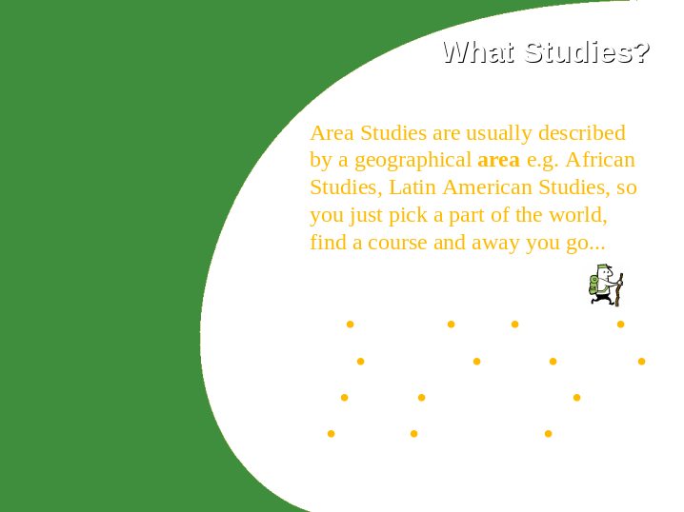

With this slide you can make it clear also that students won’t find any degree programme entitled ‘Area Studies’ but that this is the name for a type of degree and that most programmes are defined by a geographical area, e.g. to study Africa look for African Studies. In the slides for a particular area examples of (your) degree programmes can be included.

Figures from UCAS on applications by subject etc. at: http://www.ucas.ac.uk/figures/

For a fuller description of Area Studies see the Area Studies benchmarking statement www.qaa.ac.uk

If you have replaced Area with the title of your area you may wish to delete this slide or adapt it to include information on that area, e.g. what countries in Africa your course covers or what European Studies includes.
Slide 3

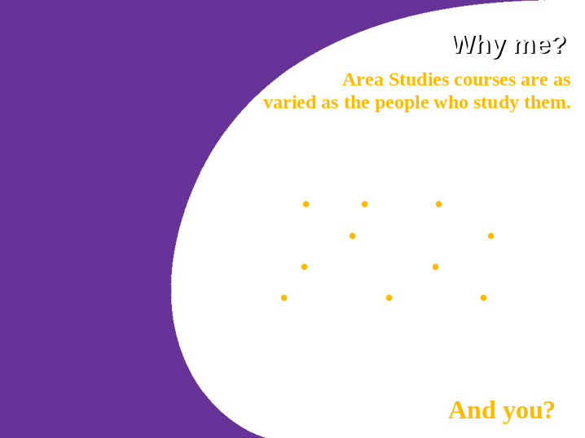

The articles from which these quotes are taken can be found at www.
They include American Studies, Middle Eastern and African Studies, European Studies, Latin American Studies, Russian and East European Studies…
You may wish, therefore to only include the student attributes associated with your area
You could ask students to guess what type of people might be interested in Area/your area Studies before you show them the slide.
Slide 4



You may wish to unpack the terms interdisciplinary and multidisciplinary in a way that will be more accessible to young people, or delete them altogether. What you may wish to emphasise is that these type of degree can be very broad and will suit students with wide interests esp. now that they are doing more AS levels..
You may also invite listeners to talk about their own interests and which they would like to pursue. Alternatively you might like to invite them to suggest which subjects contribute to Area/your area studies.

For more on interdisciplinarity see: www.lang.ltsn.ac.uk/as/arealinks.html#interdis

Slide 5

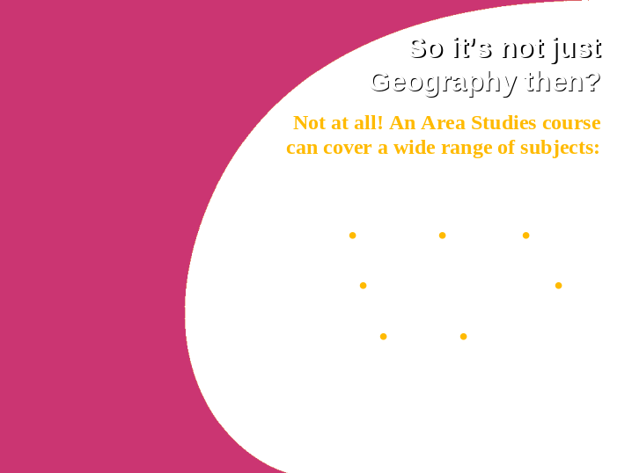

Any others? Should business go in there?
Should there be more details?
Anthropology may need to be explained.
Slide 6



You may wish/need to describe what this knowledge and these skills might be, e.g. [knowledge] what is Third World debt, why is the USA the major economic power in the world today, the politics of the EU.
[skills] linguistic, communication, negotiation, intercultural awareness...
Slide 7



It would be useful to have some information about what employers might be looking for in a graduate with this type of background.
Any information you have on graduate careers in your area could be inserted here. If you have contacts with employers through work placements etc. it might be useful to ask them for a few soundbites on what they value in your students/graduates
Slide 8



It would be interesting for students to see a few profiles of past students - what they studied, what they are doing now and how they felt their degree contributed to their employment.
If you can get quotes from students about what they hope to do as a career and why they chose Area/your area studies they could be inserted here.
Any high profile media person, politician etc. who has studied your area would be also worth mentioning at this point.
You may also wish to ask your audience what their career aspirations are before you show the slide.
Slide 9



Without getting too polemical it may be useful to encourage the audience to reflect on their experiences of travel and how they reacted to the cultures they have experienced. Also to explore bigger questions of colonialism and its effect on our society and on that of others e.g. the slave trade.

The potential for travel is a big selling point for some students, but could frighten off the more timid ones who may be daunted by the prospect of a trip to Africa, so it may be worth mentioning that travel is not always compulsory.
Some may also be put off by the costs of travel to non-European destinations so it might be useful to mention any schemes you know about to help with this or to highlight the possibility of making contact with communities from the area being studied who are resident in the UK.

More on residence abroad can be found at: www.lang.ltsn.ac.uk/abroad/
Slide 10



The benefit of being adventurous is worth emphasising for those who see this as appealing.
It may be worth asking them where they have travelled and where they most dream of going and why?
Any quotes from students in you area can replace those given.

Item 8 in the pack contains more quotes that can be added here

Slide 11



This is a tricky one which undergraduates probably only realise once they have returned from being abroad or are nearing the end of their studies, so it may need some extra explanation along the lines of looking at what we think of as ‘normal’ in our society/culture and what happens when we go to other cultures where there version of normal is slightly or completely different. You could ask the students to talk about what they have found strange on their travels and what travellers may find strange here.

Item 8 in the pack contains more quotes that can be added here
Slide 12



The ‘added value’ of a language learning experience is worth emphasising (even if languages are not normally part of your area of study). Most universities offer language courses and these are generally popular as a means of adding something extra to a degree. You could talk about the way in which learning a language helps you see things from a different perspective, helps you to create relationships with others (not just sexual ones, of course) and helps in the job market where open-mindedness, good communication and the ability to work internationally are valued.
Slide 13



These quotes come from the Independent at www. You may wish, of course to add your own as they relate to your area. You might also wish to talk about why you took up the study of your area.
Slide 14

Slide 15



This list can be added to or adapted to your target audience. You may wish to poll listeners as to how interested they might be in thinking about a degree in your or another area. It may also be useful to find out what they are planning to do (if not an area) to give yourself an idea of what the most popular degree courses are (e.g. single discipline v multi-discipline)

